// **WAP in Joomla to change Templates Styles (site).**

Step 1 - First of all, you need to log in to the admin dashboard. Then, on the toggle menu, let’s go to System -> Site Template Styles.

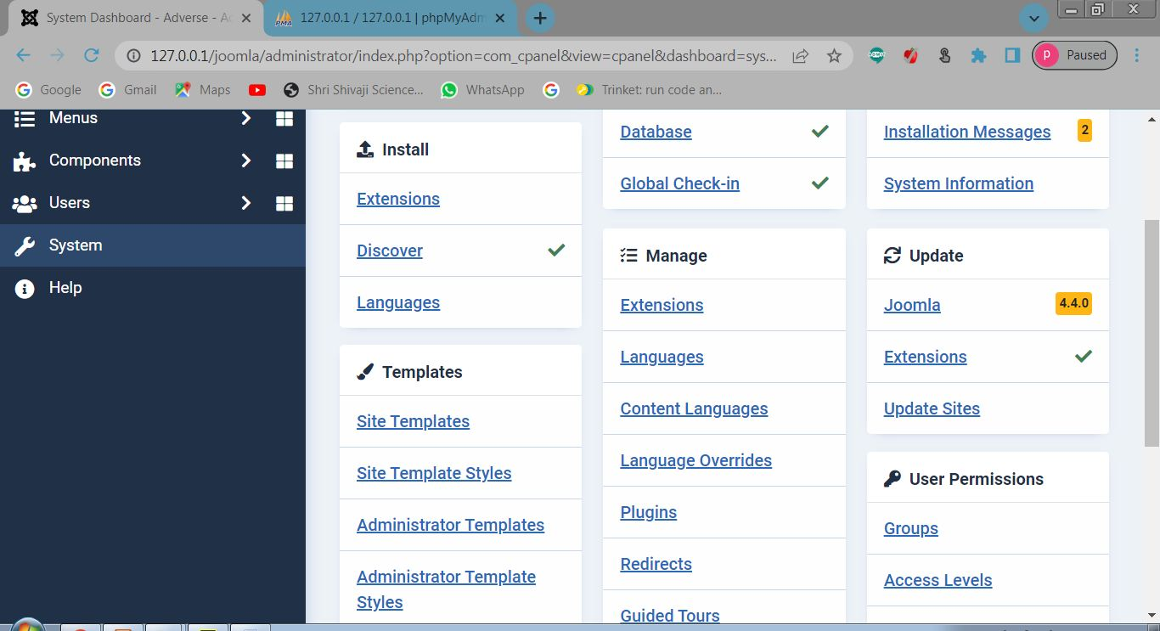

Step 2-Now, you just need to click on Cassiopeia – Default to continue the logo-changing process.

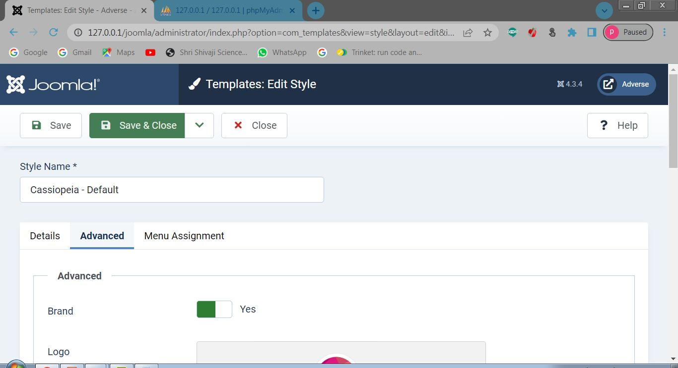

Step 3- In the next step, simply go ahead with the Advanced tab. So, you can easily see the place to add your own logo here.

Let’s press the Select button to upload or insert the logo.

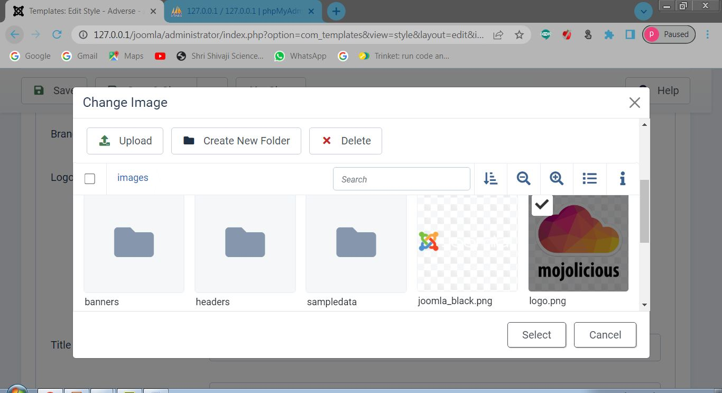

Step 4- The last step, of course, is saving all your settings to store the logo.

It’s time for you to visit your site and see how the logo change.

